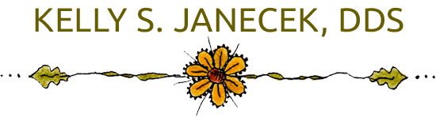

1498 S. St Francis Dr. Santa Fe, NM. 87505

(505) 986-6073

**Cancellation Policy**

Your appointment is a time reserved for you. We require at least 48-hour notice should you need to change or cancel your appointment. This allows us to accommodate individuals who would like a sooner appointment**. A fee of $75.00 will be added to your account for any missed or cancelled appointment with less than 48-hour notice**. Automated messages and calls are a courtesy provided by our office. Please do not rely solely on these reminders to notify you of your scheduled appointment. There can be unforeseen circumstances that may interfere with our ability to contact you. We will do our best to confirm your appointment either by phone, text message or e-mail. Please provide current contact information and notify us of any changes.

**Payments**

**Full payment is due at the time of professional services are rendered.**

In the event your account has un unpaid balance greater than 90 days, your account will be turned over to a collection agency. You will be responsible for any fees incurred with this process.

**Insurance**

We are a participating provider for **DELTA DENTAL (Premier Plan)**. The estimated portion of dental services not covered by your insurance company is due at the time of services are rendered. In the event your insurance company has not made payment for services rendered within 60 days of treatment, the balance will become your responsibility and will be due within 30 days.

For other insurance companies. We can assist you by submitting an electronic claim for services rendered as well as any necessary supporting documents.

-------------------------------------------------------------------------------------------------------------

I have read and agree to the above office polices as set forth by Kelly S. Janecek, DDS. I understand that they will be enforced, as necessary.

_____________________________ ___________________

Patient Signature Date