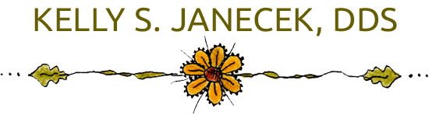

**AUTHORIZATION FOR RELEASE OF DENTAL RECORDS**

1. I, __________________________________ hereby give my consent to Dr ______________________

to release my dental records to Dr ___________________________________ Phone __________________

Address______________________________________ Email_____________________________

1. Information from and copies of the Dental Health records of:

Patient Name_______________________________________________________________________

Birth Date _____________________

Phone _________________________

1. Patient authorizes Dr. ___________________________ to release his/her Dental Records including information related to HIV infection or AIDS, any communicable disease or infectious disease and any other Dental or Health care records, in any format.
2. The Dentist and his/her employees are released from legal responsibility or liability for the release of the above information to the extent indicated and authorized herein.

Patient or Patient Representative ________________________________________ Date ________________

Patient Representative (if applicable) ______________________________ Relationship ________________________

**Dr. Kelly Janecek DDS**

**1498 S. St Francis Dr.**

**Santa Fe, NM 87505**

**(505) 986-6073**

**Janecekdds@gmail.com**